


TARUCHINA CASHEW GROWERS ASSOCIATION OF TANZANIA (TCGA)

COMPANY

PROFILE

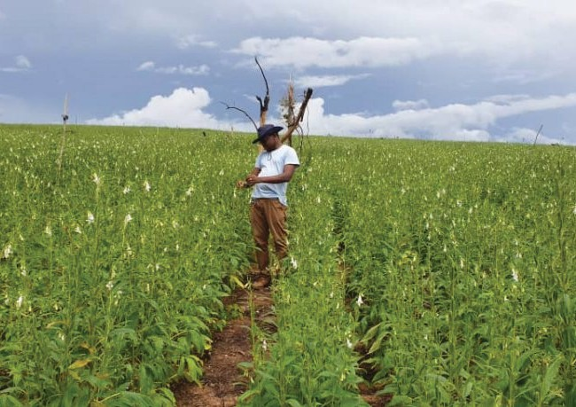

2 TARUCHINA CASHEW GROWERS ASSOCIATION OF TANZANIA (TCGA)



ABOUT TARUCHINA CASHEW GROWERS ASSOCIATION OF TANZANIA (TCGA)

TARUCHINA is the acronym of the names representing TANDANGONGORO, RUAHA, CHIKONJI and NANDAMBI wards in Lindi Region in Tanzania. TCGA was registered in June, 2019 as company limited by guarantee under Tanzania Companies Act 2002. Its registration certificate number is 139320549. The Association is formed by cashew farmers aiming to address key challenges such as reliable cashew markets, subsidized cost of production, storage facilities and use of modern technology such as tractors and irrigation machine. Other challenges include availability of farm services such as farm extension services, fumigation and insecticides management services, financial services and infrastructure development. TCGA acts as a linkage forum between farmers and development stakeholders such as Development and Investment Banks, Donors, Policy makers and Government, Statistic Bureau etc. TCGA currently has 250 members who in total own 45,000 acres of land potential for cashew farming. Out of 45,000 acres, 12,000 acres are surveyed farms and hold at least 250,796 cashew trees.
The remaining acres are at different stages of cultivation, planting and surveying. TCGA owns one company - Tanzania Cashew Growers PLC (TCG Plc). The Company was registered on February 2021 (certificate of incorporation number 150783860) under Company Act, 2002 and the Company is Public.
The Association has its headquarters at Lindi Municipality. It has one branch office in Dar es Salaam Region – Ilala City.

TARUCHINA CASHEW GROWERS ASSOCIATION OF TANZANIA (TCGA) 3

MISSION, VISION & VALUES

Our Mission
Impove profitability of cashew farming through Promoting investment, trade and linkage of
stakeholdersIn the cashew value chain.

Our Vision
To be a leading Company in Cashew value chain and management

Core Values
- Integrity • Integrity

- Quality Products

  - Commitment
- Technology
- Customer Focused

We Offer Our Services Under Principles Of
- Professionalism
- Responsiveness
- Quality

4 TARUCHINA CASHEW GROWERS ASSOCIATION OF TANZANIA (TCGA)

SERVICES OFFERED BY TARUCHINA CASHEW GROWERS ASSOCIATION OF TANZANIA

Farm Development

Members Advocacy






Furmigation Services

TARUCHINA CASHEW GROWERS ASSOCIATION OF TANZANIA (TCGA) 5

SERVICES OFFERED BY
TANZANIA CASHEW GROWERS Plc
Services Offered by Tanzania Cashew Growers PLC , this Company is commercial Company owned by TCGA members by 51% and 49% potential investors.

Supply of farm input
Cashew Processing Industry






Storage facility Marketing

Research and Development

TARUCHINA CASHEW GROWERS ASSOCIATION OF TANZANIA (TCGA)


7
TARUCHINACASHEWGROWERSASSOCIATIONOFTANZANIA(TCGA)

FARM
DEVELOPMENT
As professionals in cashew value chain TCGA provide services on various chain in Cashew sector and other inter crops grown in farms of TCGA farm members. TCGA collaborates with development partners and various researchers to support Farmers to increase production of Cashew and guide on how Farmers will Reduce production cost.



MEMBER
ADVOCACY
TCGA engage in reviewing various policies and regulation that leads cashew sector in Tanzania for interest of Cashew farmers and submit to various Government policy makers for Consideration, however the various meeting stakeholders organized to view various potential available in cashew sector.

8 TARUCHINA CASHEW GROWERS ASSOCIATION OF TANZANIA (TCGA)

SUPPLY OF

FARM INPUT
Farm input includes pesticides, seedlings and fertilizers. In a view to establishing modern cashew farm, TCG Plc will make sure Farmers use a recommended Pesticides and Agricultural best practices recommended by Researchers.
Overall objectives of provision of farm input service:
+ To ensure farmers use modern and researched seedlings.
+ To control pests, insects, fungus timely.
+ To reduce farming cost.

9 TARUCHINA CASHEW GROWERS ASSOCIATION OF TANZANIA (TCGA)



10
TARUCHINA CASHEW GRTOAWNZERASNAIASSCOACSHIAETWIOGNROOFWTEARNSZPALNCIA(T(CTGCGPLAC) )7

WHY USE OF FARM INPUT?
+ Because each farmer or any investor need to regain capital that is used in the cashew farming.
+ Because farmers are obliged to control farm diseases.
+ Because cashew farming is huge business and needs to be operated scientifically for desired output.




CASHEW PROCESSING INDUSTRY

This is the center of our core service. TCG PLC expects to build marquee industry with capacity of processing 5,000 MT by year 2023, and up to 25,000 metric
tons by the year 2025. The company has already secured 10 acres at Lindi Municipal for building this Industry.

The company is also negotiating with different financial institutions to be part of this project. The industry expects to collect TCGA cashew, process and pack for internal and external market. Moreover, it expects to create employment for both skilled and unskilled
workers.

11 GROWERS ASSOCIATION OF TANZANIA (TCGA)

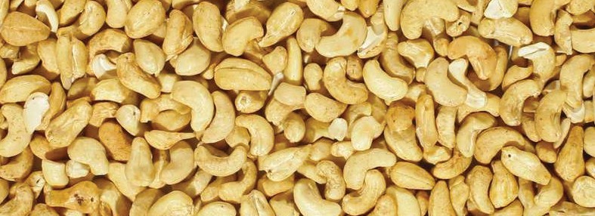

WHY BUILD PROCESSING INDUSTRY?
+ Because there is currently deficit of cashew processing factory in Tanzania when compared to actual cashew output.
+ With value addition on chain in Cashew sector will increase prices to Farmers and create employment to youth and Women.
+ Because Tanzania government has recently pointed industry to be the driver of economy.
+ The Government Vision for 2020-2025 is Industrization.

TARUCHINA CASHEW GROWERS ASSOCIATION OF TANZANIA (TCGA) 11

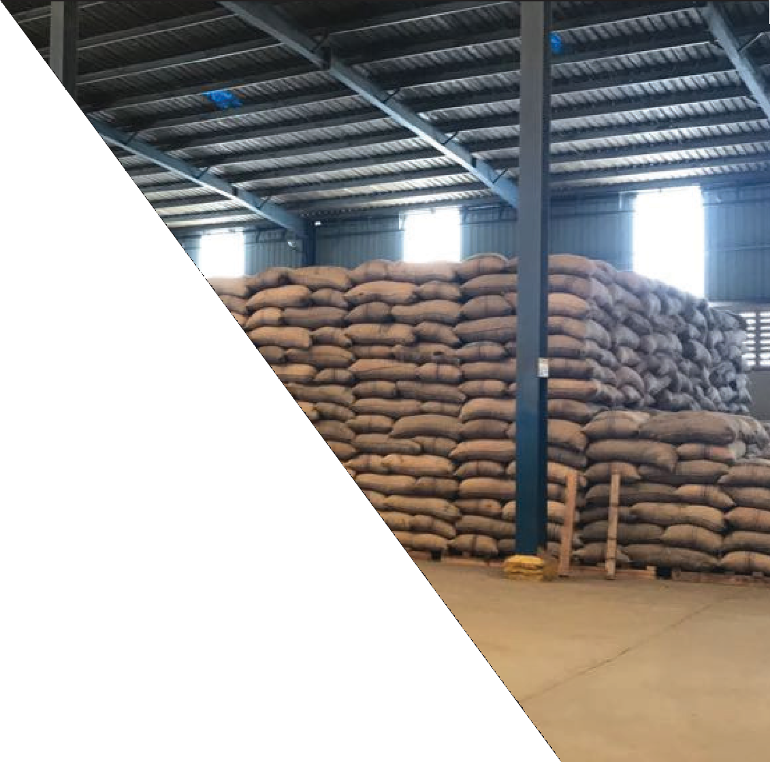

STORAGE FACILITY
Due to massive production of cashew nut in Tanzania there has always been shortage of storage facility. TCG Plc plans to build Storage warehouses at various Areas where TCGA members
are producing raw Cashewnuts to reduce high cost occured on storage facilities.

12 TARUCHINA CASHEW GROWERS ASSOCIATION OF TANZANIA (TCGA)

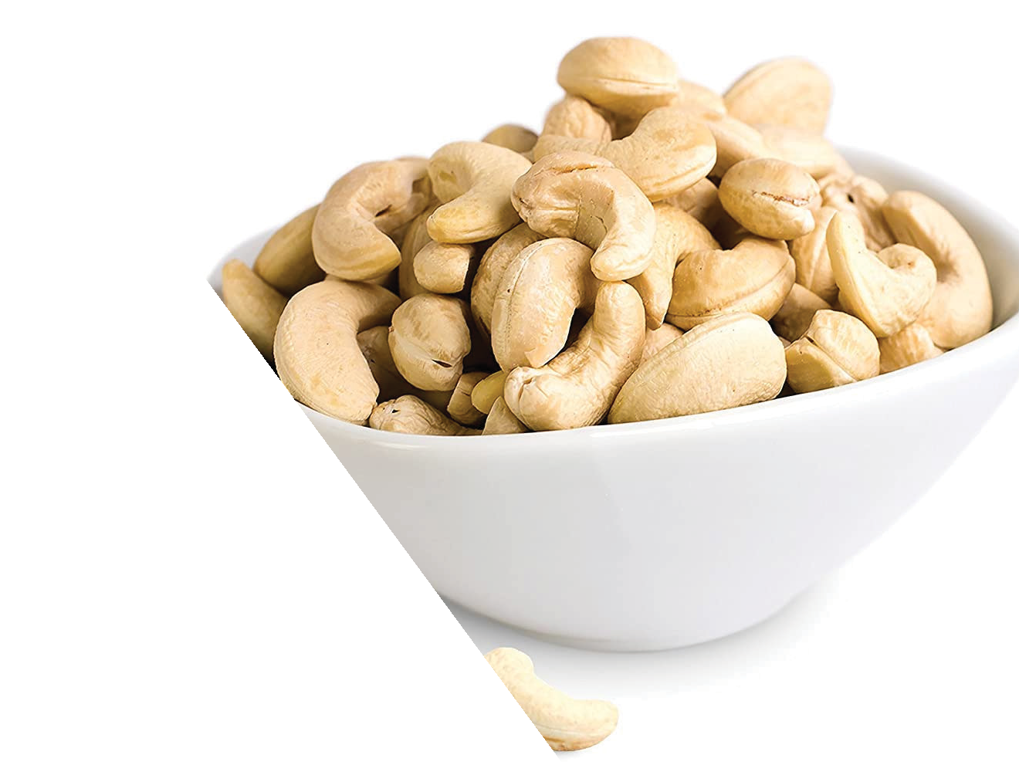

BENEFITS OF
STORAGE FACILITY
It is a legal requirement in the cashew value chain to store cashewnut in authorized storage facility.
The buildings therefore have the following benefits;
- Farmers will store their cashew nut as recommended by Tanzania Cashew Board and therefore avoid losses which generate from improper storageof cashew nut.
- Reduced haulage cost from the farm to the collection center.
- Source of income to TCG Plc.

13 TARUCHINA CASHEW GROWERS ASSOCIATION OF TANZANIA (TCG14A)

MARKETING
Our Understanding and Knowledge. TCG PLC has a team understanding well the Current Cashew Industry and therefore has Prepared machineries to enable secure markets Locally and Globally. Our product ranges from Cashewnut to by products. We are designed to let each Cashew Harvested is processed before it is being exported.











15 TARUCHINA CASHEW GROWERS ASSOCIATION OF TANZANIA (TCGA)



WHY MARKETING?
- Because cashew sector has experienced price instability for a number of years. Marketing comes in as a solution to processed product instead of RCN
- Because TCG Plc believes in contract farming and hence the products need to reach final consumers as per agreement.
- Because Tanzania needs to regain its share in cashew production worldwide. Marketing and branding play vital role in informing the world about cashew farming in Tanzania

TARUCHINA CASHEW GROWERS ASSOCIATION OF TANZANIA (TCGA) 16


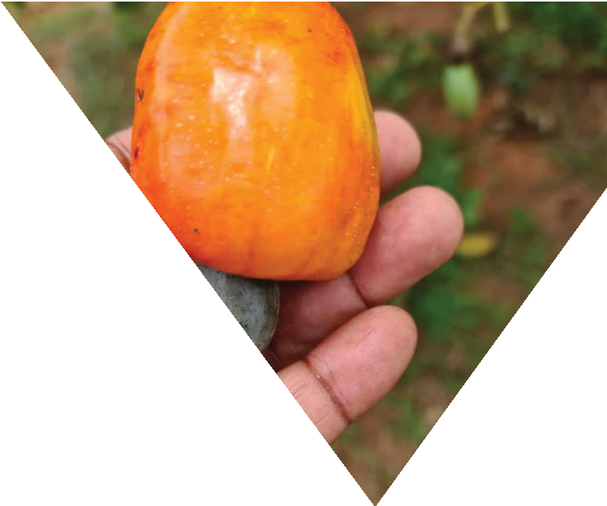
17
TARUCHINA CASHEW GROWERS ASSOCIATION OF TANZANIA (TCGA)



RESEARCH AND DEVELOPMENT

We collaborate with TARI-Naliendle Agriculture Training Institute and Tanzania Cashew Board in;
  - Growing and supply of modern seedlings to TCGA members and general public.
  - Mobilize each TCGA member to allocate few acres and grow cashew model farm for seedling production and learning purposes.
  - Research of new pesticides for cashew growing purposes.
  - Providing opportunities for graduates and academicians



CONSULTANCY
We provide consultancy services in cashew value chain. Our services range as follows;
- New cashew farm planning and development.
- Application of farm in put such as pesticides control.
- Cashew information gathering for different uses especially in TCGA member farms.

18 TARUCHINA CASHEW GROWERS ASSOCIATION OF TANZANIA (TCGA)

ORGANIZATION STRUCTURE OF
TARUCHINA CASHEW GROWERS ASSOCIATION OF TANZANIA (TCGA)

ANNUAL GENERAL MEETING

TARUCHINA CASHEW GROWERS ASSOCIATION OF TANZANIA BOARD OF DIRECTORS

TANZANIA CASHEW GROWERS PUBLIC LIMITED COMPANY BOARD OF DIRECTORS
COMPANY SECRETARY

DIRECTOR GENERAL

CHIEF EXECUTIVE OFFICER

DIRECTORATE OF INTERNAL AUDIT

DIRECTORATE OF BUSINESS OPERATIONS DIRECTORATE OF FARM DEVELOPMENT
CHIEF FINANCE OFFICER

PLANNING AND INVESTMENT MANAGER

PRODUCTION AND OPERATION MANAGER

BUSINESS AND FINANCE MANAGER

MAR ETING AND COMMUNICATION MANAGER

MEMBERSHIP, POLICY AND PLANNING MANAGER

FARM DEVELOPMENT MANAGER

GRANTS AND PROJECTS MANAGER

PROCUREMENT AND LOGISTIC MANAGER

ADMINISTRATION MANAGER

MAR ETING OFFICER

COMMUNICATION AN PUBLICITY OFFICER

MEMBERSHIP, POLICY AND PLANNING OFFICER

EXTENSION OFFICER GRANTS OFFICER

PROCUREMENT AND LOGISTIC OFFICER

STORE

ADMINISTRATION OFFICER

OFFICE ASSISTANCE

LOGISTIC OFFICER

AGRICULTURAL EDUCATION OFFICER

PROJECT OFFICER

MONITORING AND EVALUATION OFFICER

ACCOUNTANTS CASHIER
COMMUNICATION AND EXTERNAL AFFAIRS OFFICER

TARUCHINA CASHEW GROWERS ASSOCIATION OF TANZANIA (TCGA) 19



OUR TEAM

Our team is composed of Senior qualified professionals in Business and Cashew Industry. We are assured of researching, Developing products and services that meet customers demand. Our expertise in
Cashew farming, Cashew Management, Bargaining Technics, Marketing skills, Logistic and Storage experience brings a composite, That is essential in running Cashew Business.

Our team is assured of working with investors, academicians, researchers and general public to ensure the Cashew sector is promoted in Tanzania.

20 TARUCHINA CASHEW GROWERS ASSOCIATION OF TANZANIA (TCGA)

EDUCATION QUALIFICATION AND SKILLS
OF TARUCHINA BOARD MEMBERS

MUHIDIN ABDI MURO (MR)
Chairman
QUALIFICATION
+Master of Public
Administration
EXPERIENCE
Has experience of 13 years in:-
+ Human resource and Administration
+ Labour Laws and Conflict resolution Specialis
+ Procurement and Tender Board Member

ADV. MAGDALENA KAMUGISHA RWEBANGIRA
Vice Chairperson

CPA JONAS
QUALIFICATION
+ Master of Philosophy in Law

QUALIFICATION
EXPERIENCE
Has experience of 25 years in:-
+ Labour Laws and Conflict resolution Specialist
+ Procurement Skills and Leadership
+ Corporate advisor gender, development and human rights issues.
+ Company and Commercial law Skills
+ Advocacy Skills

EXPERIENCE

TULUHUNGWA
Financial Controller
+ MBA - Corporate Management
+ Certified Public Accountant
Has experience of 14 years in:-
+ Auditing and Assurance Services
+ Experiance in Project and Budgeting
+ Experiance in Risk analysis

21 TARUCHINA CASHEW GROWERS ASSOCIATION OF TANZANIA (TCGA)

EDUCATION QUALIFICATION AND SKILLS
OF OUR TEAM

ARCH. ROMWALD BYARUGABA
Member
QUALIFICATION
+ Msc. Construction Economics
and Management
EXPERIENCE
Has more than 7 years in :-
+ Architecturial Science
+ Training and Capacity Building in Architecture services

ENG. SUPHIAN S. MBWANA
Member
QUALIFICATION
+Msc. Information Technology and Management
EXPERIENCE
Has more than 10 years in :-
+ Telecommunication & IT Operations management.
+ Project Management Specialist
+ Member ERB, IET & PMI (Tanzania Chapter)

REHEMA MASHAKA MBUGI
Member

CPA LULUMARIA KIMAMBO
Member
QUALIFICATION
+ Bsc. Business Statistics
+ Diploma in Public Private Dialogue

QUALIFICATION
+ MBA - Finance
+ Certified Public Accountant
EXPERIENCE
+ Private Sector Development Specialist
+ Public Policy Analysis,communication,business environment analysis,communication,research, planning and coordination,management,advocacy, Public-Private Dialogue

EXPERIENCE
Has more than 10 years in :-
+ Complex architecturial design in Private and Public projects, Building Economist,
+ Project Management Professional

22 TARUCHINA CASHEW GROWERS ASSOCIATION OF TANZANIA (TCGA)

EDUCATION QUALIFICATION AND SKILLS
OF TARUCHINA MANAGEMENT TEAM

CPA VICTORIUS P. KAMUNTU
Chief Executive Officer

CPA AUGUSTUS C. MACHUMI
Director
Business Operation

MNOCHE MNOCHE
Program Coordinator
QUALIFICATION
+Msc. Applied Economics and
Business
+ Certified Public Accountant
+ Diploma in IPSAS

QUALIFICATION
+ Msc. Accounting and Finance
+ Certified Public Accountant

QUALIFICATION
+ Bsc. Agriculture General
EXPERIENCE
Has more than 12 years in :-
+ Venture Development
+ Projects Business & Appraisal
+ Management & Leadership
+ Financial Analysis Skills
+ Tax Laws Skills

EXPERIENCE
Has more than 11 years in :
+ Business Consulting
+ Finance & Accounting
+ Project & Business Plan Consultant
+ Organisation skills
EXPERIENCE
Has more than three years in:-
+ Agriculture Extensionist
+ Monitoring & Evaluation

23 TARUCHINA CASHEW GROWERS ASSOCIATION OF TANZANIA (TCGA)

EDUCATION QUALIFICATION AND SKILLS
OF TARUCHINA MANAGEMENT TEAM

SAUDA MAKWISA
Accountant

JUMA FANDE
Marketing Officer

REHEMA JUMA
Sales Attendant

TUMAINI MAKWASA
Supervisor
QUALIFICATION
+Bachelor of Accounting

QUALIFICATION
+ Diploma in General
Agriculture

QUALIFICATION
+ Certificate in Pesticides
management

QUALIFICATION
+ Diploma in Procurement
and Supply
EXPERIENCE
Has more than two years in :-
+ Accounting
+ Taxation and BusinessCompliance

EXPERIENCE
Has more than 2 years in:-
+ Pesticides Management
+ Seed and Crop Management
+ Fertilizer Management

EXPERIENCE
Has more than 2 years in:-
+ Toxic and Poison Management
+ Secretarial Course

EXPERIENCE
+ Research and Data Entry
+ Pests Management and Control
+ Store Management
+ Clearing and Fowarding

24 TARUCHINA CASHEW GROWERS ASSOCIATION OF TANZANIA (TCGA)

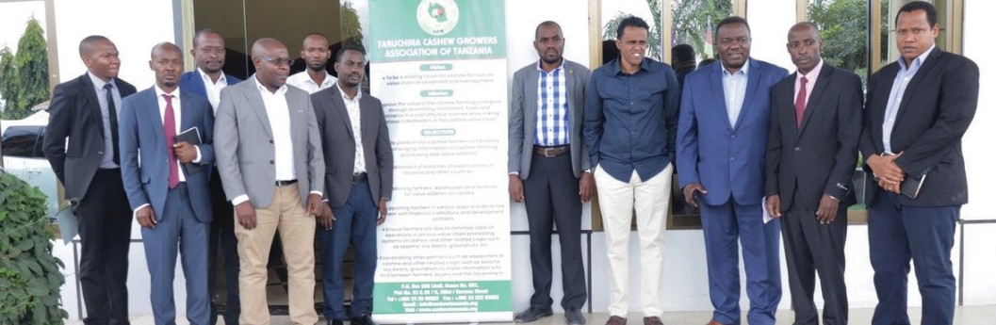
25
TARUCHINA CASHEW GROWERS ASSOCIATION OF TANZANIA (TCGA)

POTENTIAL INVESTORS
TCGA welcomes all potential investors to collaborate with Cashew farmers Association to work with especially in the following areas:-
Cashew Processing industries , Suppliers of Machines and simple technology for removing stamps in farms and sprays , Partners that are ready to work with Association in areas of farm inputs businesses in Tanzania,Companies to supply mashines used in value chain of processing of cashew,And potential investors that are ready to be part of ownership of Tanzania Cashew Growers PLC owned by Association by 51%

What we offer to Potential Investors
Land for construction of factories, warehouses and areas for construction farm inputs factory in Tanzania and Assured to provide farm markets for farm inputs in Tanzania

OUR ADDRESS & CONTACTS


LINDI HEAD QUARTERS
Taruchina Cashew Growers Association of Tanzania, House No. 007, Plot No. 23&25/B, Elliet/Karume Street,
P.O.Box 658, Lindi Tanzania, Tel: +255 232202022 Fax: +2552322202022
E-Mail info@cashewtanzania.org Website: www.cashewtanzania.org
DAR ES SALAAM BRANCH
Taruchina Cashew Growers Association of Tanzani House No. 12, Plot No. 24/25 Shingo Feni Street Off Buguruni Road, Ilala
P.O.Box Dar es Salaam
Mob: +255 783 925 862/ +255 753 767 824.
E-Mail: ceo@cashewtanzania.org

